

National Textile University
Department of Computer Science
Subject
Mobile Application
Submitted to:
Rehan Sarwar
Submitted by:
Abid Ali
Registration Number
23-NTU-CS-1124
lab No.
04
Semester
6th
Task 1
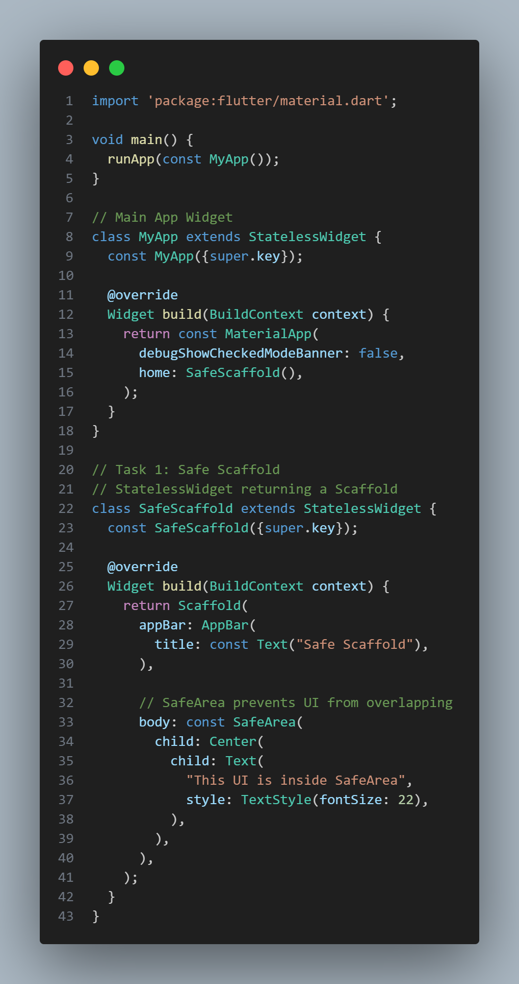
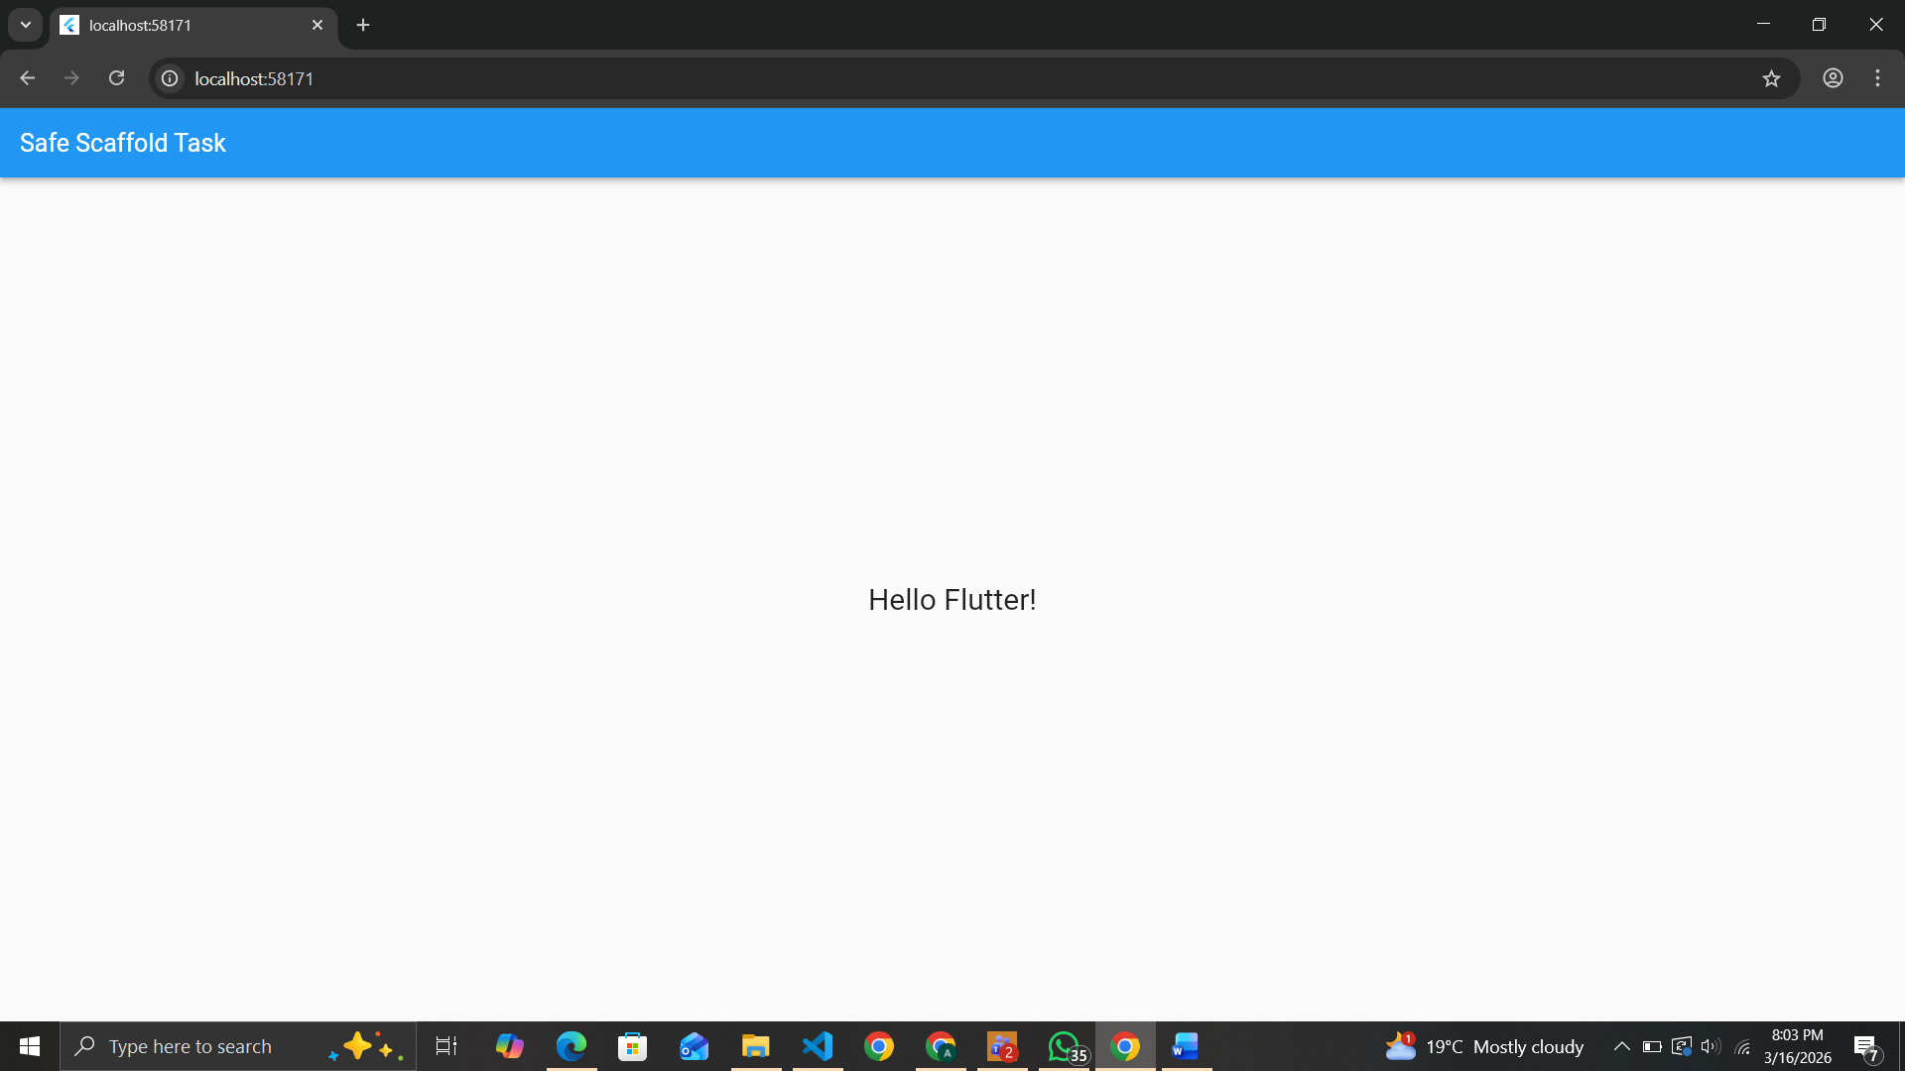
Task 2
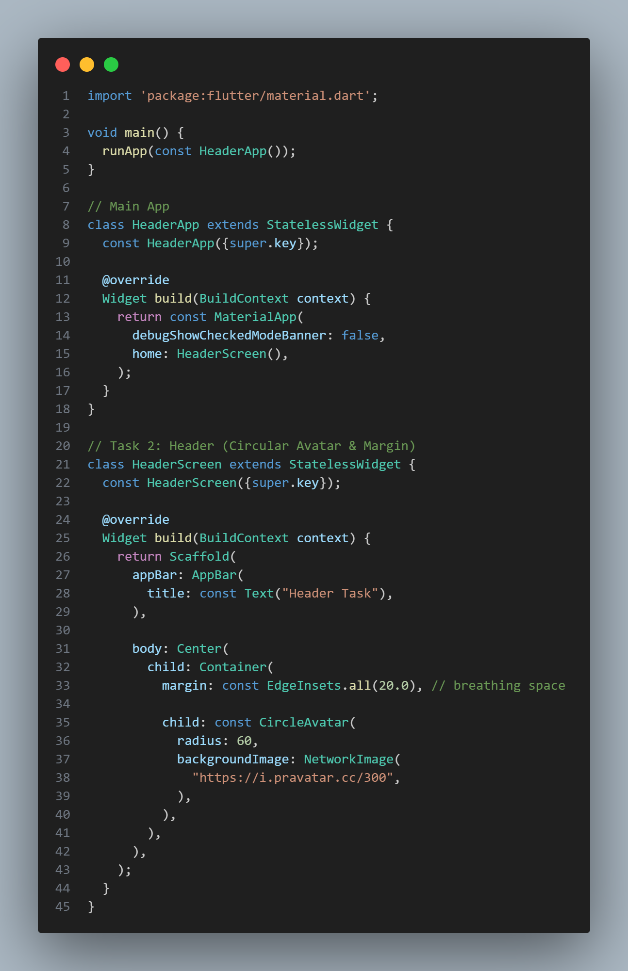
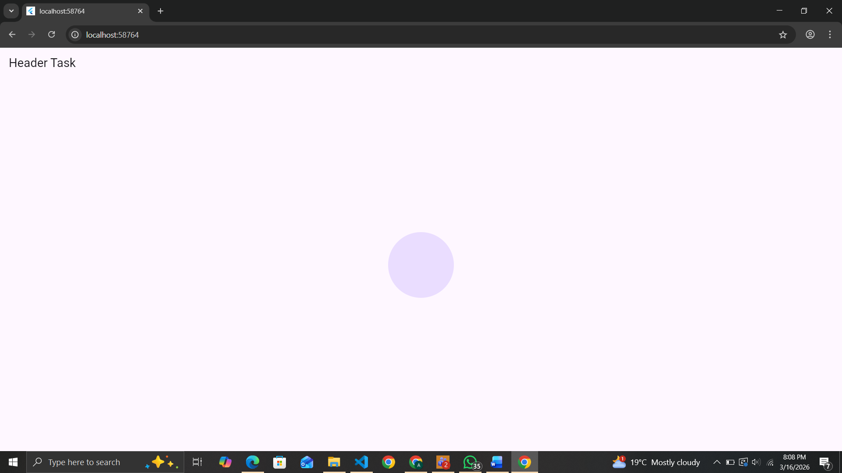

Task 3

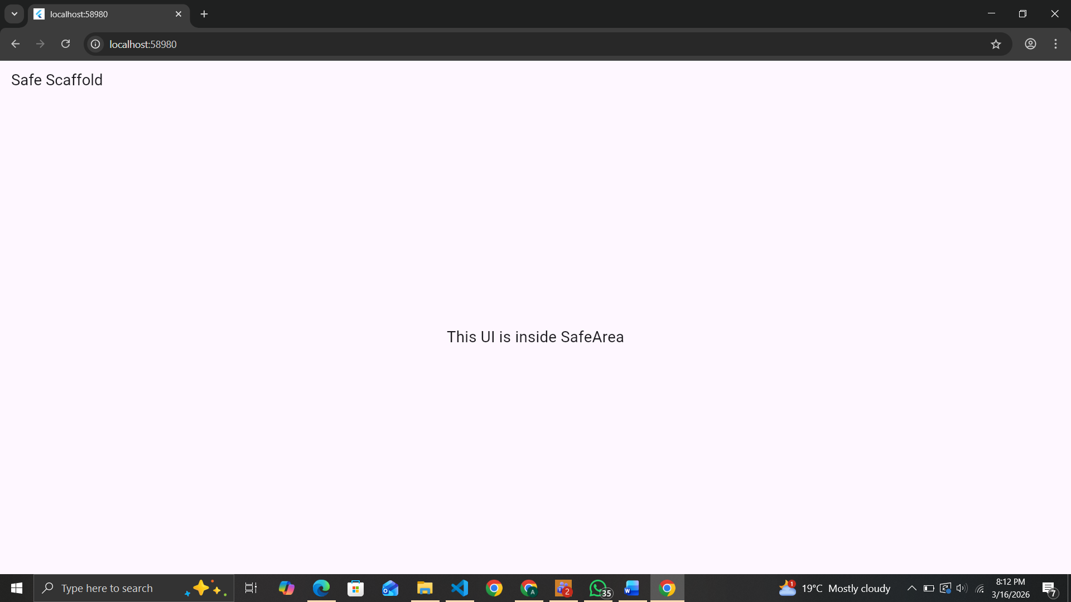
Task 4
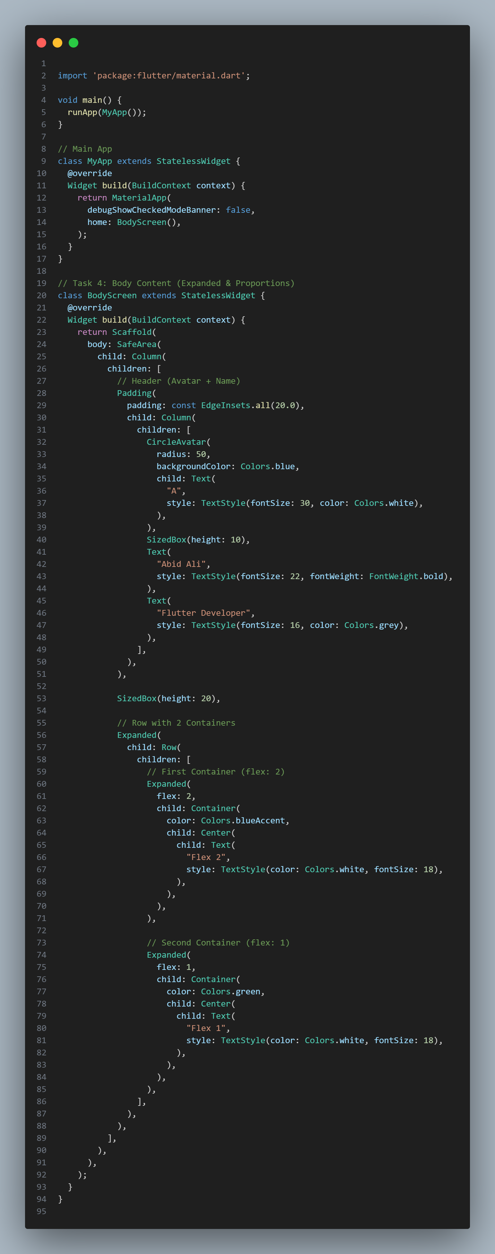
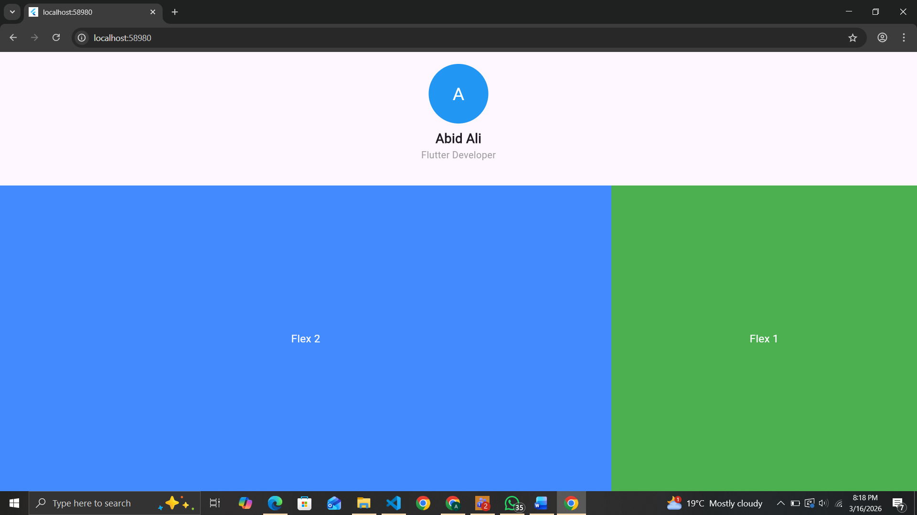
Task 5

import 'package:flutter/material.dart';

void main() {
runApp(MyApp());
}

// Main App
class MyApp extends StatelessWidget {
@override
Widget build(BuildContext context) {
return MaterialApp(
debugShowCheckedModeBanner: false,
home: SizedBoxScreen(),
);
}
}

// Task 5: Spacing with SizedBox
class SizedBoxScreen extends StatelessWidget {
@override
Widget build(BuildContext context) {
return Scaffold(
body: SafeArea(
child: Column(
crossAxisAlignment: CrossAxisAlignment.center,
children: [
SizedBox(height: 20), // Top space

CircleAvatar(
radius: 50,
backgroundColor: Colors.blue,
child: Text(
"A",
style: TextStyle(fontSize: 30, color: Colors.white),
),
),

SizedBox(height: 15), // Space between Avatar & Name

Text(
"Abid Ali",
style: TextStyle(fontSize: 22, fontWeight: FontWeight.bold),
),

SizedBox(height: 8), // Space between Name & Title

Text(
"Flutter Developer",
style: TextStyle(fontSize: 16, color: Colors.grey),
),

SizedBox(height: 30), // Space before next widget

Container(
height: 50,
width: 200,
color: Colors.green,
child: Center(
child: Text(
"Button Placeholder",
style: TextStyle(color: Colors.white, fontSize: 18),
),
),
),
],
),
),
);
}
}

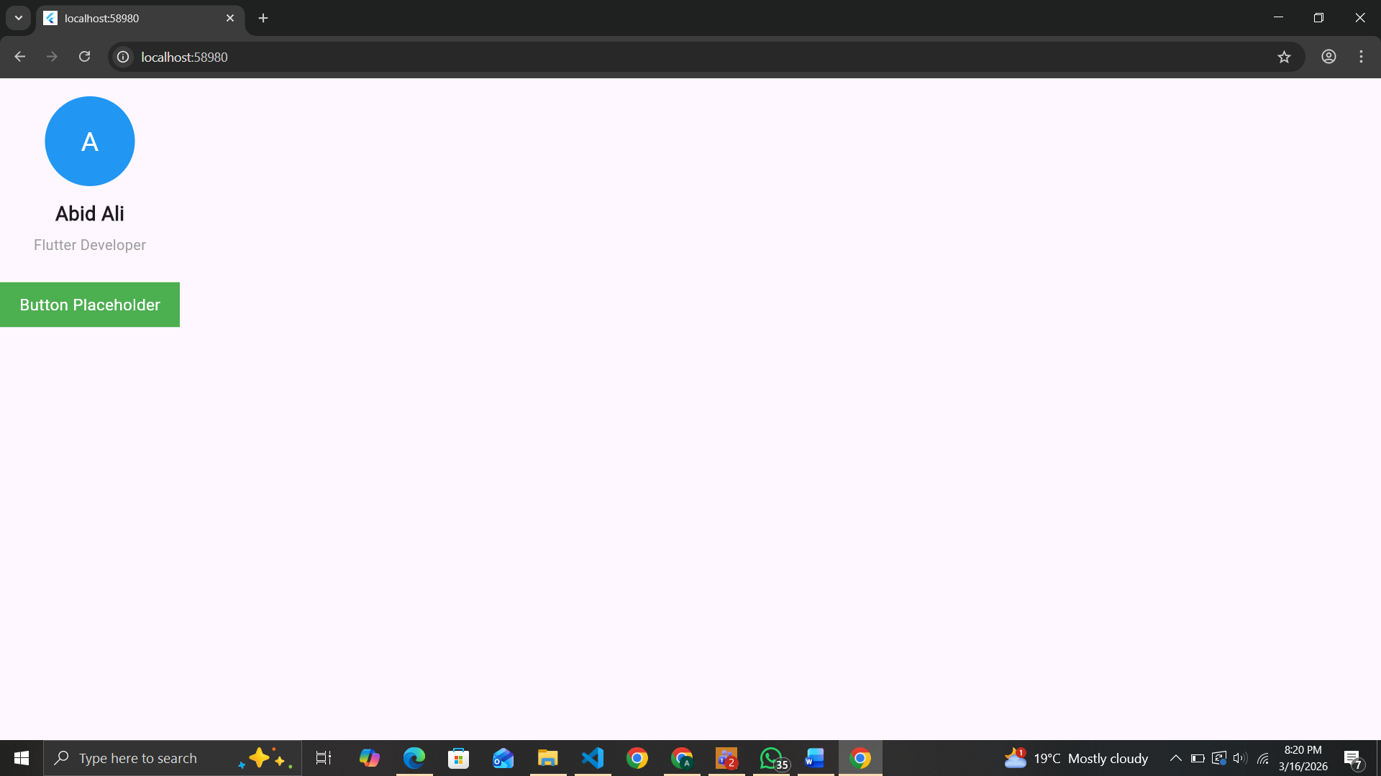
Task 6
import 'package:flutter/material.dart';

void main() {
runApp(MyApp());
}

// Main App
class MyApp extends StatelessWidget {
@override
Widget build(BuildContext context) {
return MaterialApp(
debugShowCheckedModeBanner: false,
home: FollowScreen(),
);
}
}

// Task 6: Refactoring to StatefulWidget
class FollowScreen extends StatefulWidget {
@override
_FollowScreenState createState() => _FollowScreenState();
}

class _FollowScreenState extends State<FollowScreen> {
// Variables required by the task
bool isFollowed = false;
int score = 0;

@override
Widget build(BuildContext context) {
return Scaffold(
appBar: AppBar(
title: Text("Stateful Widget Task"),
),
body: Center(
child: Column(
mainAxisSize: MainAxisSize.min,
children: [
CircleAvatar(
radius: 50,
backgroundColor: Colors.blue,
child: Text(
"A",
style: TextStyle(fontSize: 30, color: Colors.white),
),
),
SizedBox(height: 10),
Text(
"Abid Ali",
style: TextStyle(fontSize: 22, fontWeight: FontWeight.bold),
),
SizedBox(height: 5),
Text(
"Score: $score",
style: TextStyle(fontSize: 18, color: Colors.grey),
),
SizedBox(height: 15),
ElevatedButton(
onPressed: () {
// Toggle isFollowed and increment score
setState(() {
isFollowed = !isFollowed;
if (isFollowed) {
score += 1;
} else {
score -= 1;
}
});
},
child: Text(isFollowed ? "Unfollow" : "Follow"),
),
],
),
),
);
}
}
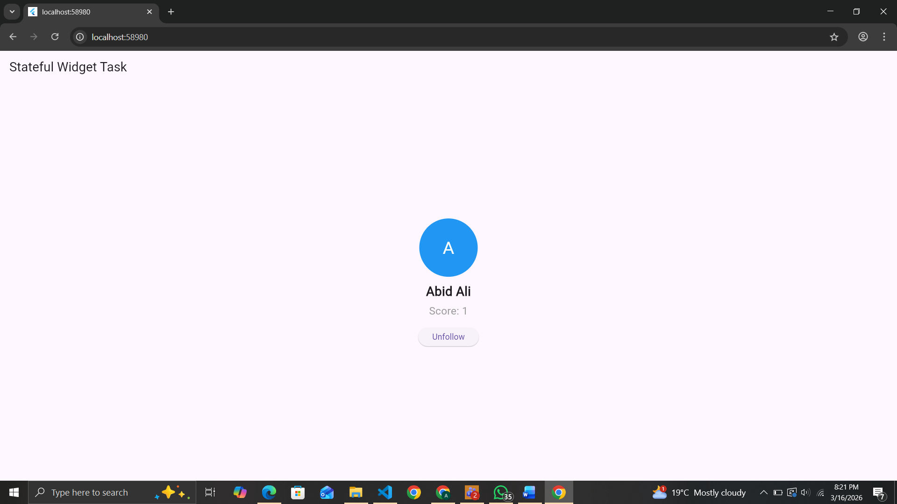
Task 7
import 'package:flutter/material.dart';

void main() {
runApp(MyApp());
}

// Main App
class MyApp extends StatelessWidget {
@override
Widget build(BuildContext context) {
return MaterialApp(
debugShowCheckedModeBanner: false,
home: ButtonsScreen(),
);
}
}

// Task 7: Material Buttons & setState
class ButtonsScreen extends StatefulWidget {
@override
_ButtonsScreenState createState() => _ButtonsScreenState();
}

class _ButtonsScreenState extends State<ButtonsScreen> {
bool isFollowed = false;
int score = 0;

@override
Widget build(BuildContext context) {
return Scaffold(
appBar: AppBar(
title: Text("Buttons & setState"),
),
body: Center(
child: Column(
mainAxisSize: MainAxisSize.min,
children: [
// Avatar
CircleAvatar(
radius: 50,
backgroundColor: Colors.blue,
child: Text(
"A",
style: TextStyle(fontSize: 30, color: Colors.white),
),
),
SizedBox(height: 10),

// Name & Score
Text(
"Abid Ali",
style: TextStyle(fontSize: 22, fontWeight: FontWeight.bold),
),
Text(
"Score: $score",
style: TextStyle(fontSize: 18, color: Colors.grey),
),
SizedBox(height: 20),

// Buttons Row
Row(
mainAxisSize: MainAxisSize.min,
children: [
// Follow Button
ElevatedButton(
onPressed: () {
setState(() {
isFollowed = !isFollowed;
if (isFollowed) {
score += 1;
} else {
score -= 1;
}
});
},
child: Text(isFollowed ? "Unfollow" : "Follow"),
),
SizedBox(width: 20),

// Like Button
IconButton(
icon: Icon(Icons.thumb_up),
color: Colors.red,
iconSize: 30,
onPressed: () {
setState(() {
score += 1;
});
},
),
],
),
],
),
),
);
}
}
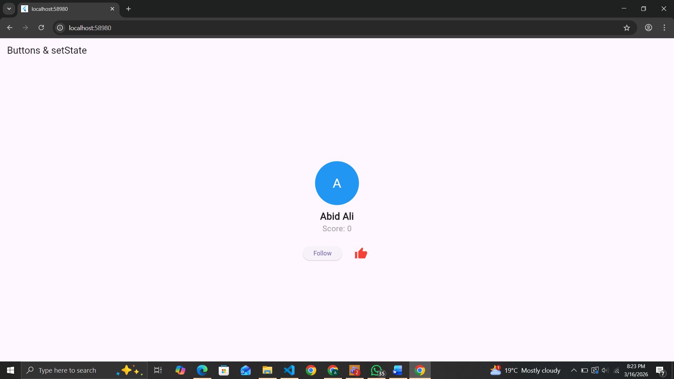

Task 8
import 'package:flutter/material.dart';

void main() {
runApp(MyApp());
}

// Main App
class MyApp extends StatelessWidget {
@override
Widget build(BuildContext context) {
return MaterialApp(
debugShowCheckedModeBanner: false,
home: CardScreen(),
);
}
}

// Task 8: Material Card Implementation
class CardScreen extends StatefulWidget {
@override
_CardScreenState createState() => _CardScreenState();
}

class _CardScreenState extends State<CardScreen> {
bool isFollowed = false;
int score = 0;

@override
Widget build(BuildContext context) {
return Scaffold(
appBar: AppBar(
title: Text("Card Task"),
),
body: Center(
child: Column(
mainAxisSize: MainAxisSize.min,
children: [
// Avatar
CircleAvatar(
radius: 50,
backgroundColor: Colors.blue,
child: Text(
"A",
style: TextStyle(fontSize: 30, color: Colors.white),
),
),
SizedBox(height: 10),

// Name
Text(
"Abid Ali",
style: TextStyle(fontSize: 22, fontWeight: FontWeight.bold),
),
SizedBox(height: 20),

// Card for statistics
Card(
elevation: 5, // shadow
margin: EdgeInsets.symmetric(horizontal: 40),
child: ListTile(
leading: Icon(Icons.score, color: Colors.orange),
title: Text("Score"),
subtitle: Text("$score"),
),
),

SizedBox(height: 20),

// Follow Button
ElevatedButton(
onPressed: () {
setState(() {
isFollowed = !isFollowed;
if (isFollowed) {
score += 1;
} else {
score -= 1;
}
});
},
child: Text(isFollowed ? "Unfollow" : "Follow"),
),
],
),
),
);
}
}
